Nama : Anita Siagian

Quality Engineer

**PART A –Input/Output, Error Message, Comment, Branching, Looping**

1. **Problem 1 – Menghitung Luas Segitiga**

Program :

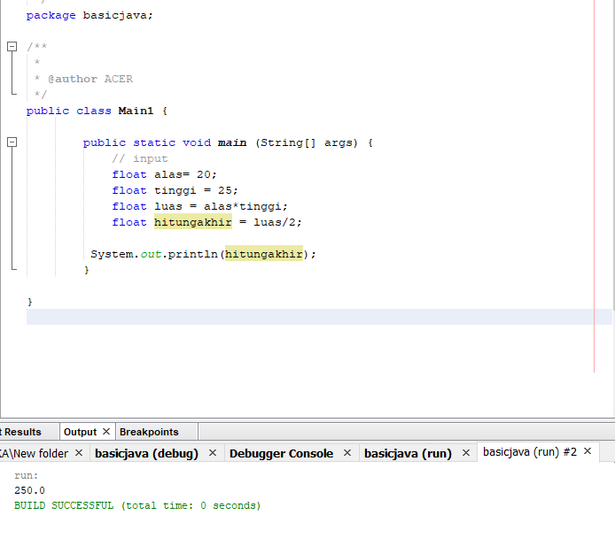

1. **Problem 2 Konversi Nilai**

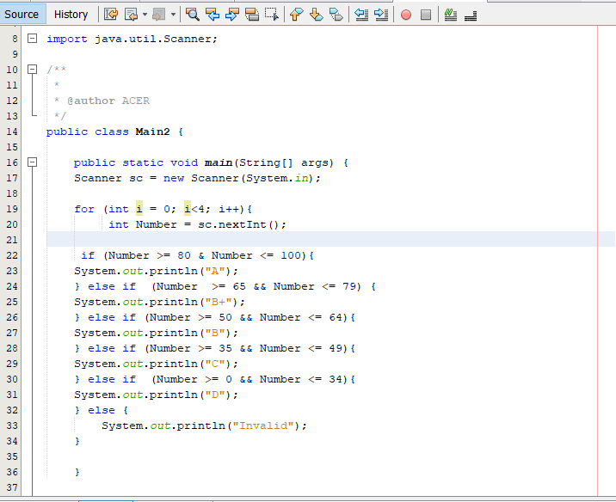

Hasil :

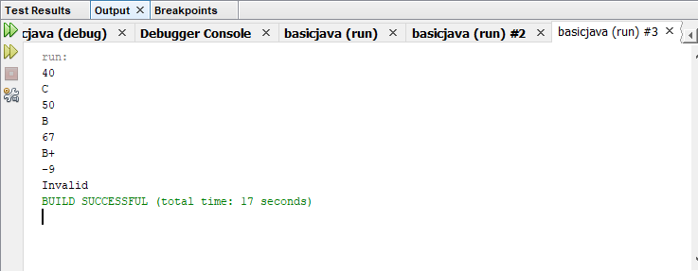

1. **Problem 3 – Faktor Bilangan**

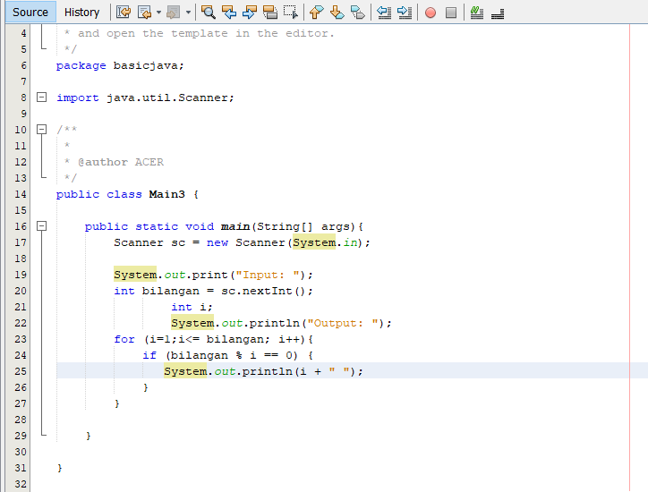

Hasil :

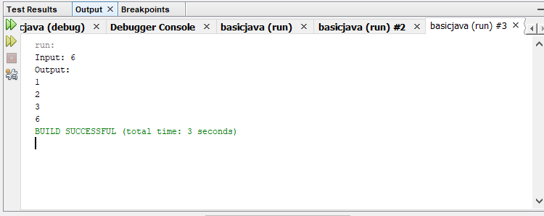

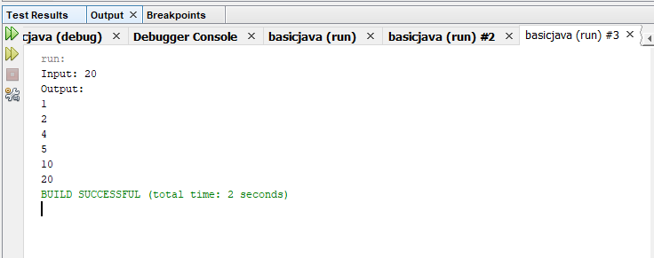

1. **Problem – Faktor Bilangan II**

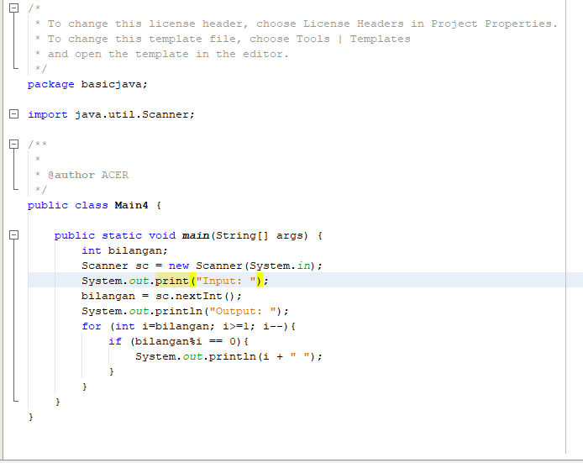

Hasil :

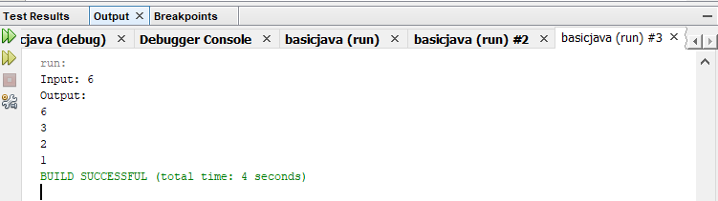

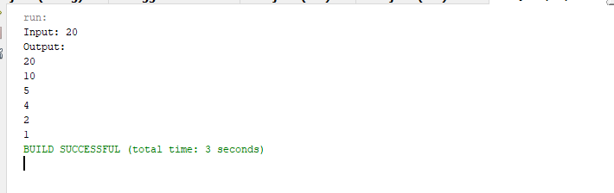

1. **Problem 5- Bilangan Prima**

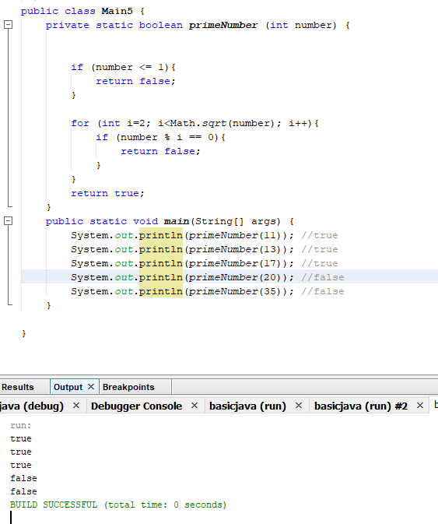

1. **Problem 6 – Palindrome**

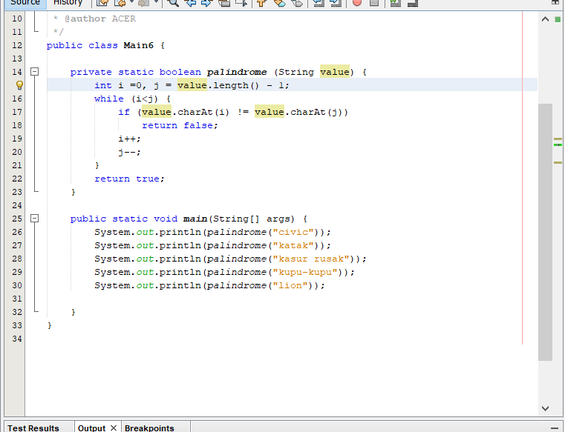

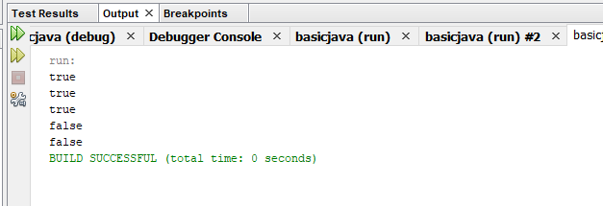

**PART B – Branching, Looping, Array**

**Problem 1 – Exponentiation**

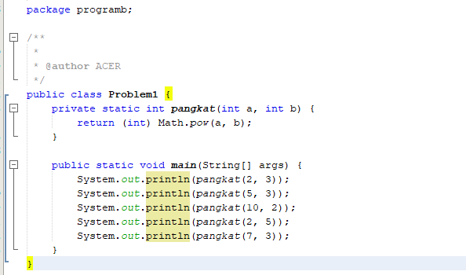

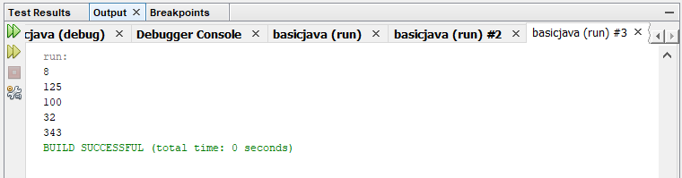

**Problem 2 – Play With Asterisk**

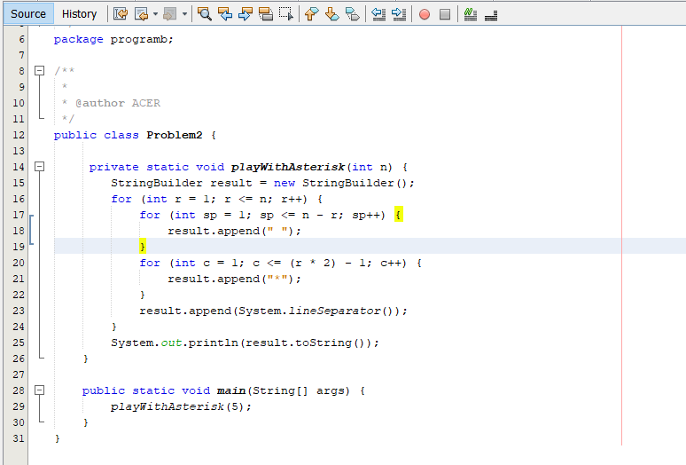

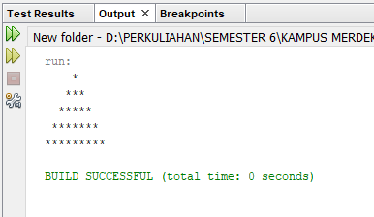

**Problem 3 - Draw XYZ**

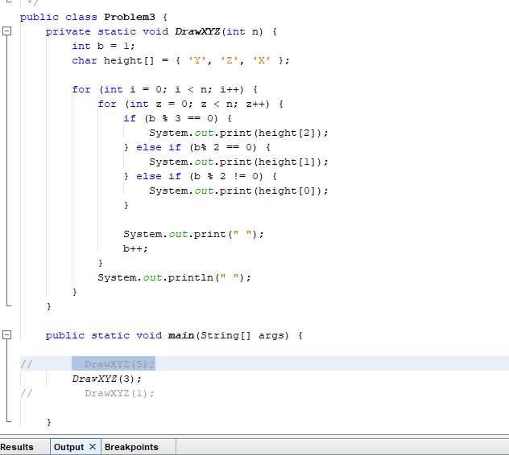**\**

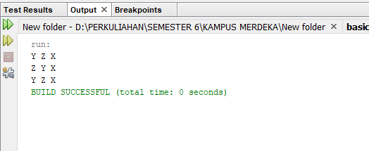

**Problem 4 – Cetak Tabel Perkalian**

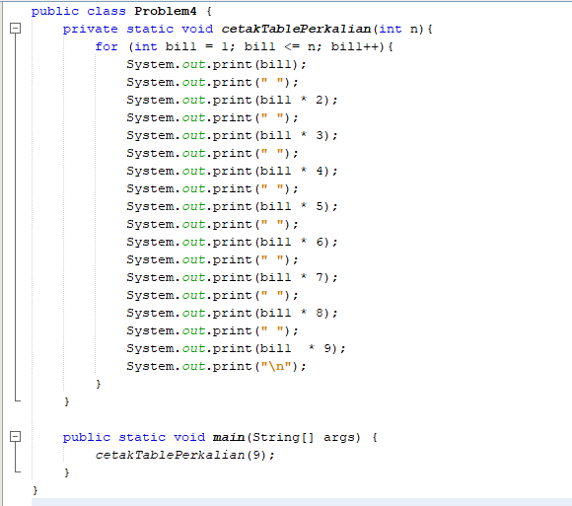

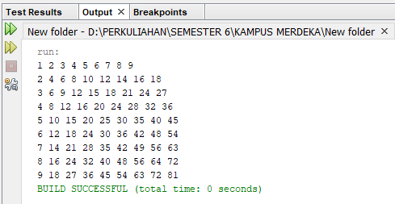

**Problem 5 – Ubah Huruf**

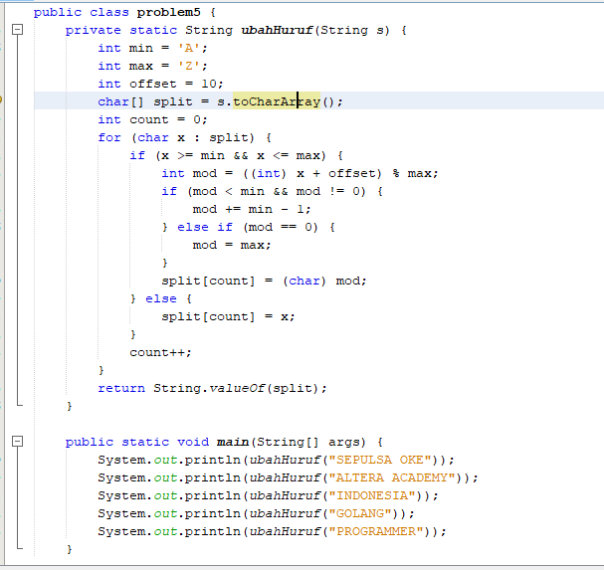

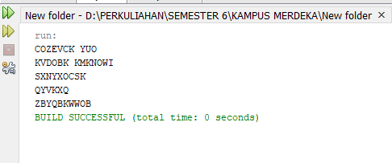

**Problem 6 – Mean**

